CHSP AND HACC FINANCIAL HARDSHIP POLICY AND PROCEDURE
Umbrella Multicultural Community Care Services Inc.
Document Name | CHSP and HACC Financial Hardship Policy and Procedure | Approved by | Chief Executive Officer
Category | Client Services – Fees and Contributions | Endorsed by | Head of Finance and Operations
Original Date | 1 August 2026 | Version | 01
This Review | 4 August 2026 | Next Review Due | August 2028, or earlier if triggered
Applies To | All clients receiving Commonwealth Home Support Programme (CHSP) or Home and Community Care (HACC) services, and all Umbrella staff involved in discussing, assessing or recording client contributions. | Key Legislation | Aged Care Act 2024, Aged Care Rules 2025, CHSP Program Manual, CHSP Client Contribution Framework, Strengthened Aged Care Quality Standards, Privacy Act 1988.
Contents
1. Purpose
2. Scope
3. Legislative and regulatory context
4. Key definitions
5. Our principles
6. Roles and responsibilities
7. Identifying financial hardship and providing information
8. Receiving the application and gathering evidence
9. Assessment criteria and possible outcomes
10. Decision and notification
11. The financial hardship procedure at a glance
12. Review and appeals
13. Confidentiality and privacy
14. Record keeping and audit evidence
15. Review of this policy and procedure
16. Associated documents
17. References
Appendix A: Financial Hardship Assessment Outcome letter

1. Purpose
Every client receiving services through the Commonwealth Home Support Programme (CHSP) or the Home and Community Care (HACC) program is asked to contribute to the cost of their care, where they are able to. This policy and procedure sets out how Umbrella Multicultural Community Care Services Inc. (Umbrella) ensures no eligible client is disadvantaged, denied services, or refused care because of genuine financial hardship.
It describes the principles Umbrella applies to client contributions, how a financial hardship application is assessed, and the process staff follow, from a client first raising a concern about cost through to a documented, reviewable outcome.
2. Scope
This policy and procedure applies to all clients receiving Commonwealth Home Support Programme and Home and Community Care government funded services through Umbrella, and to all Umbrella staff involved in discussing, assessing or recording client contributions and financial hardship, including Care Partners, Administration staff, Senior Managers and the Chief Executive Officer.
3. Legislative and Regulatory Context
Umbrella's approach to client contributions and financial hardship is shaped by the following:
- Aged Care Act 2024 (Cth), which establishes CHSP as an approved government funded aged care program and sets a general statutory duty on providers to act in the best interests of the people in their care.
- Aged Care Rules 2025 (Cth), which set out the detail of provider conditions of registration.
- The CHSP Program Manual and the CHSP Client Contribution Framework, published by the Australian Government Department of Health, Disability and Ageing, which require CHSP providers to have a documented, publicly available client contribution policy, and to consider each client's capacity to pay, including through hardship provisions.
- The Strengthened Aged Care Quality Standards, in particular Standard 1 (Consumer Dignity and Choice), which requires clients to be supported to make informed choices about their care, including its cost.
- Privacy Act 1988 (Cth) and the Australian Privacy Principles, which govern how the financial and personal information collected through this process is handled.
Under the CHSP Client Contribution Framework, a client contribution must not exceed the actual cost of the service provided, and the contribution agreed with a client must be recorded in writing in their service agreement.
4. Key Definitions
Term | Meaning
Financial hardship | A situation where a client is unable to meet the standard client contribution for their CHSP or HACC services without compromising their ability to pay for essential living expenses.
CHSP contribution | The fee a client agrees to pay towards the cost of their Commonwealth Home Support Programme services, as set out in their service agreement.
Client Contribution Framework | The national framework published by the Australian Government that guides CHSP providers in setting fair, consistent and transparent client contributions.
Reasonable contribution | A contribution that reflects a client's capacity to pay, and does not exceed the actual cost of the service provided.
Hardship application | A request, made verbally, in writing or through a representative, for Umbrella to reduce, waive or defer a client's contribution due to financial hardship.
5. Our Principles
Umbrella's approach to client contributions and financial hardship is guided by the three principles in the national CHSP Client Contribution Framework, alongside Umbrella's own commitment to its clients.
- Consistency: all clients who are able to contribute to the cost of their care are asked to do so, and client contributions never exceed the actual cost of providing the service.
- Transparency: information about client contributions and financial hardship is available in an accessible format, and is explained to every client when their services begin.
- Hardship: clients who are unable to pay the standard contribution have a clear, fair pathway to have that contribution reduced, waived or deferred.
In applying these principles, Umbrella will:
- treat every hardship application respectfully and confidentially
- make sure clients understand that requesting financial hardship assistance will not affect their eligibility for services
- consider each application individually, on its own circumstances
- make decisions fairly and consistently
- continue providing services while an application is being assessed, wherever possible
- review hardship arrangements when a client's circumstances change
No client will be refused CHSP or HACC services solely because they are unable to pay the standard contribution.
6. Roles and Responsibilities
Role | Responsibility
Client or authorised representative | Completes the Financial Hardship Application, provides supporting documentation where available, and notifies Umbrella if their circumstances change.
Umbrella Care Partner and Administration | Explains the client contribution policy, provides the Financial Hardship Application, assists clients to complete it where needed, collects supporting documentation, and forwards completed applications to the authorised decision maker.
Umbrella Senior Manager | Reviews applications, assesses financial hardship objectively against the criteria in this policy, documents the reasons for each decision, notifies the client in writing, and ensures records are maintained.
Chief Executive Officer | Ensures this policy and procedure is resourced, understood and followed, and that Umbrella's client contribution arrangements remain compliant with the Aged Care Act 2024 and the CHSP Client Contribution Framework.
7. Identifying Financial Hardship and Providing Information
Financial hardship may become apparent at any point in a client's relationship with Umbrella, including during an initial assessment, a service review, a conversation about an invoice, following non payment, or when a client or their representative raises it directly. Staff should reassure clients that asking about financial hardship assistance will never affect their access to services.
Where financial hardship is identified, staff will provide the client with a copy of this policy, an explanation of why contributions are requested, the options available to them, how their information will be kept confidential, and how the outcome will be reviewed, together with the CHSP and HACC Co-Contribution Fee Consideration Form.
8. Receiving the Application and Gathering Evidence
Applications may be made verbally, in writing, through an authorised representative, or electronically, and staff should assist clients to complete the Fee Consideration Form where needed.
Supporting evidence may include a pension or concession card, a Centrelink income statement, bank statements, evidence of medical or funeral expenses, utility bills, a rental agreement or mortgage statement, or other documentation that demonstrates hardship. A lack of documentation should not, on its own, result in an application being refused where hardship is otherwise evident.
9. Assessment Criteria and Possible Outcomes
In assessing an application, Umbrella considers the client's income, essential living expenses, assets where relevant, any unexpected financial events, and their overall capacity to contribute without hardship. Each application is assessed individually and on its own merits.
Possible outcomes include a full fee waiver, a reduced contribution, a temporary fee reduction, a deferred payment arrangement, or, where the assessment does not identify hardship, the standard contribution continuing to apply. The reasons for every decision must be documented on the Fee Consideration Form.
10. Decision and Notification
The Senior Manager reviewing an application documents the decision and the reasons for it, and the client is notified in writing using the Financial Hardship Assessment Outcome letter at Appendix A, setting out the decision, its effective date, and when it will next be reviewed.
11. The Financial Hardship Procedure at a Glance
The diagram below summarises the end to end procedure, from a client first identifying hardship through to the review being scheduled.
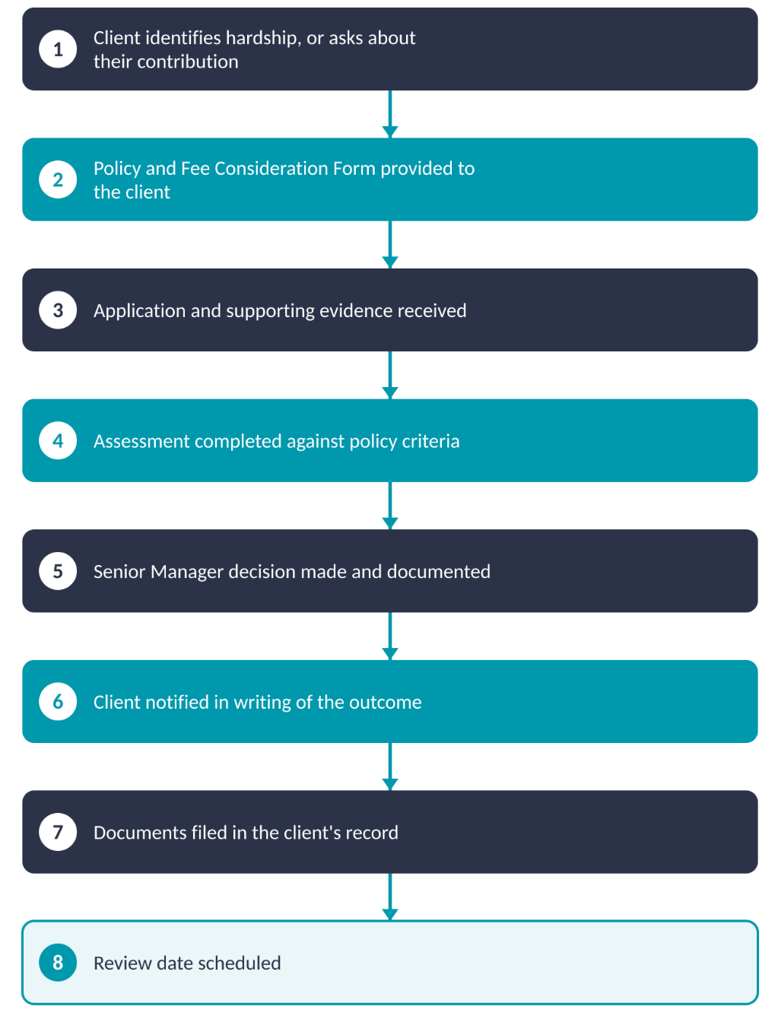
Figure 1. The Umbrella financial hardship procedure, from identification through to review.
12. Review and Appeals
Financial hardship approvals are reviewed annually, when a client's circumstances change, at the client's request, or following a significant change in income.
A client who disagrees with a decision may request a review. Reviews are carried out by a manager who was not involved in the original decision, wherever possible.
13. Confidentiality and Privacy
All financial information provided through this process is handled in accordance with the Privacy Act 1988 (Cth) and Umbrella's Privacy and Confidentiality Policy, and is only used to assess a client's contribution and hardship application.
14. Record Keeping and Audit Evidence
For every completed hardship assessment, Umbrella retains the Fee Consideration Form, supporting evidence, the documented assessment and decision, and the client's written notification, stored securely in the client's electronic record.
For each approved hardship assessment, this record should show that:
- client contributions were discussed with the client at the start of service
- the Financial Hardship Policy was provided
- the application and supporting documentation were completed
- an assessment and decision were made and documented
- the client was advised in writing
- a review date was set
- all documents were filed in the client's record
15. Review of this Policy and Procedure
This policy and procedure will be reviewed by the Compliance and Quality Assurance Manager at least every two years, or earlier where there is a material change to the Aged Care Act 2024, the Aged Care Rules 2025, the CHSP Program Manual or the CHSP Client Contribution Framework, a significant complaint or trend relating to client contributions, or findings from an internal audit or external review.
16. Associated Documents
- CHSP and HACC Co-Contribution Fee Consideration Form
- Financial Hardship Assessment Outcome letter (Appendix A)
- CHSP Client Contribution Policy
- Privacy and Confidentiality Policy
- Umbrella Code of Conduct
17. References
- Aged Care Act 2024 (Cth)
- Aged Care Rules 2025 (Cth)
- Privacy Act 1988 (Cth)
- CHSP Program Manual, Australian Government Department of Health, Disability and Ageing
- CHSP Client Contribution Framework, Australian Government Department of Health, Disability and Ageing
- Strengthened Aged Care Quality Standards, Australian Government Department of Health, Disability and Ageing, August 2025

Appendix A: Financial Hardship Assessment Outcome
Dear [Client],
Thank you for your application to Umbrella Multicultural Community Care for financial hardship assistance.
Following a review of your circumstances, we have approved the following:
☐ Full waiver of your CHSP contribution
☐ Reduced contribution to $_____ per service
This decision is effective from _________ and will be reviewed on _________.
If your financial circumstances change, or you would like this decision reviewed, please contact us.
Kind regards,
Name
Position

